Agar is medium that cures into a gelatinous form and when mixed with the proper chemicals and nutrients it provides a solid base to grow your bacterial and yeast cultures off of.

These protocols will provide guidance in making the best possible product to provide you with the best possible outcome.

What you need:

* [Petri Plates](http://www.the-odin.com/sterile-polystyrene-petri-plates-100x15-mm/)
* [LB Agar Media](http://www.the-odin.com/powdered-millers-lb-agar/)
* [Scale](http://www.the-odin.com/digital-scale-200g-max-0-01g-resolution/)
* Glassware

This guide uses LB Agar but can be done the exact same way with YPD agar.

LB AGAR from our mix is 35g to 1L of water. This protocol is going to walk you through making 5-8 plates.

YPD Agar is 65g to 1L of water. You can use tap water.

STEP 1:

Put on a pair of Nitrile gloves.

Contamination is critical, as you are providing a platform for bacteria and yeast to grow. They both exist naturally on our skin and in the air, so gloves are a necessity.

STEP 2:

If you don’t have premeasured tubes of media from The ODIN then weigh out your LB agar or YPD Agar

Pour the powder into your bottle.

Fill your bottle or container that is microwave safe with 125mL water. Use a 50mL measuring tube to help get an accurate volume.

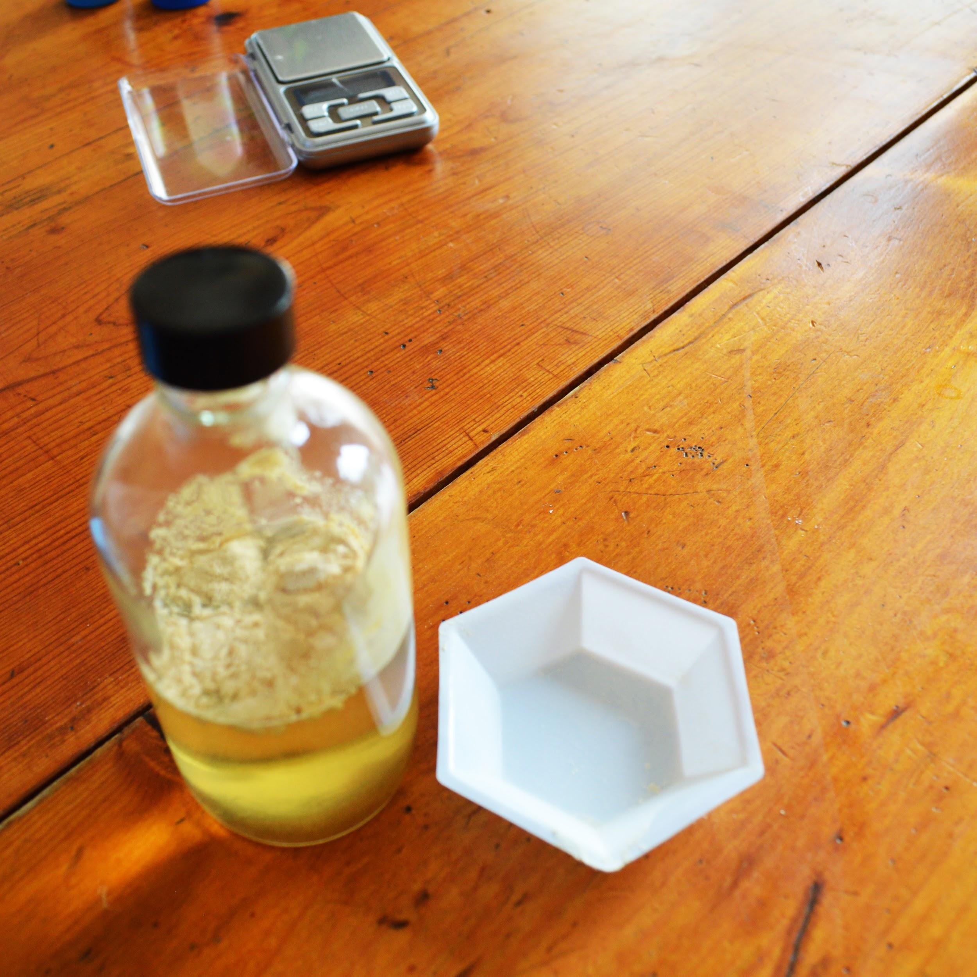

Put lid on water and gently shake the agar will look grainy in the water, that is ok. Put cap on container and barely turn it just to hold it in place. Make sure you have a towel or oven mitts to handle the bottle as it will be hot when coming from the microwave!

*Note: Do not tighten LID, can possibly make bottle explode.

Place a paper towel or napkin on the tray in the microwave. Microwave for 30 second increments on a normal setting. Stand and watch for boiling as you do not want it to boil over. Let it rest for a minute if it starts to boil and open cap to vent. Be careful if you shake the bottle when it is hot it can bubble over. The AGAR media should dissolve in 2-4 minutes. Look at the bottle and make sure you can see clearly through. Let it cool for 30 minutes or until you can hold it without discomfort.

While waiting for your media to cool clear off a counter or table and lay out your plates.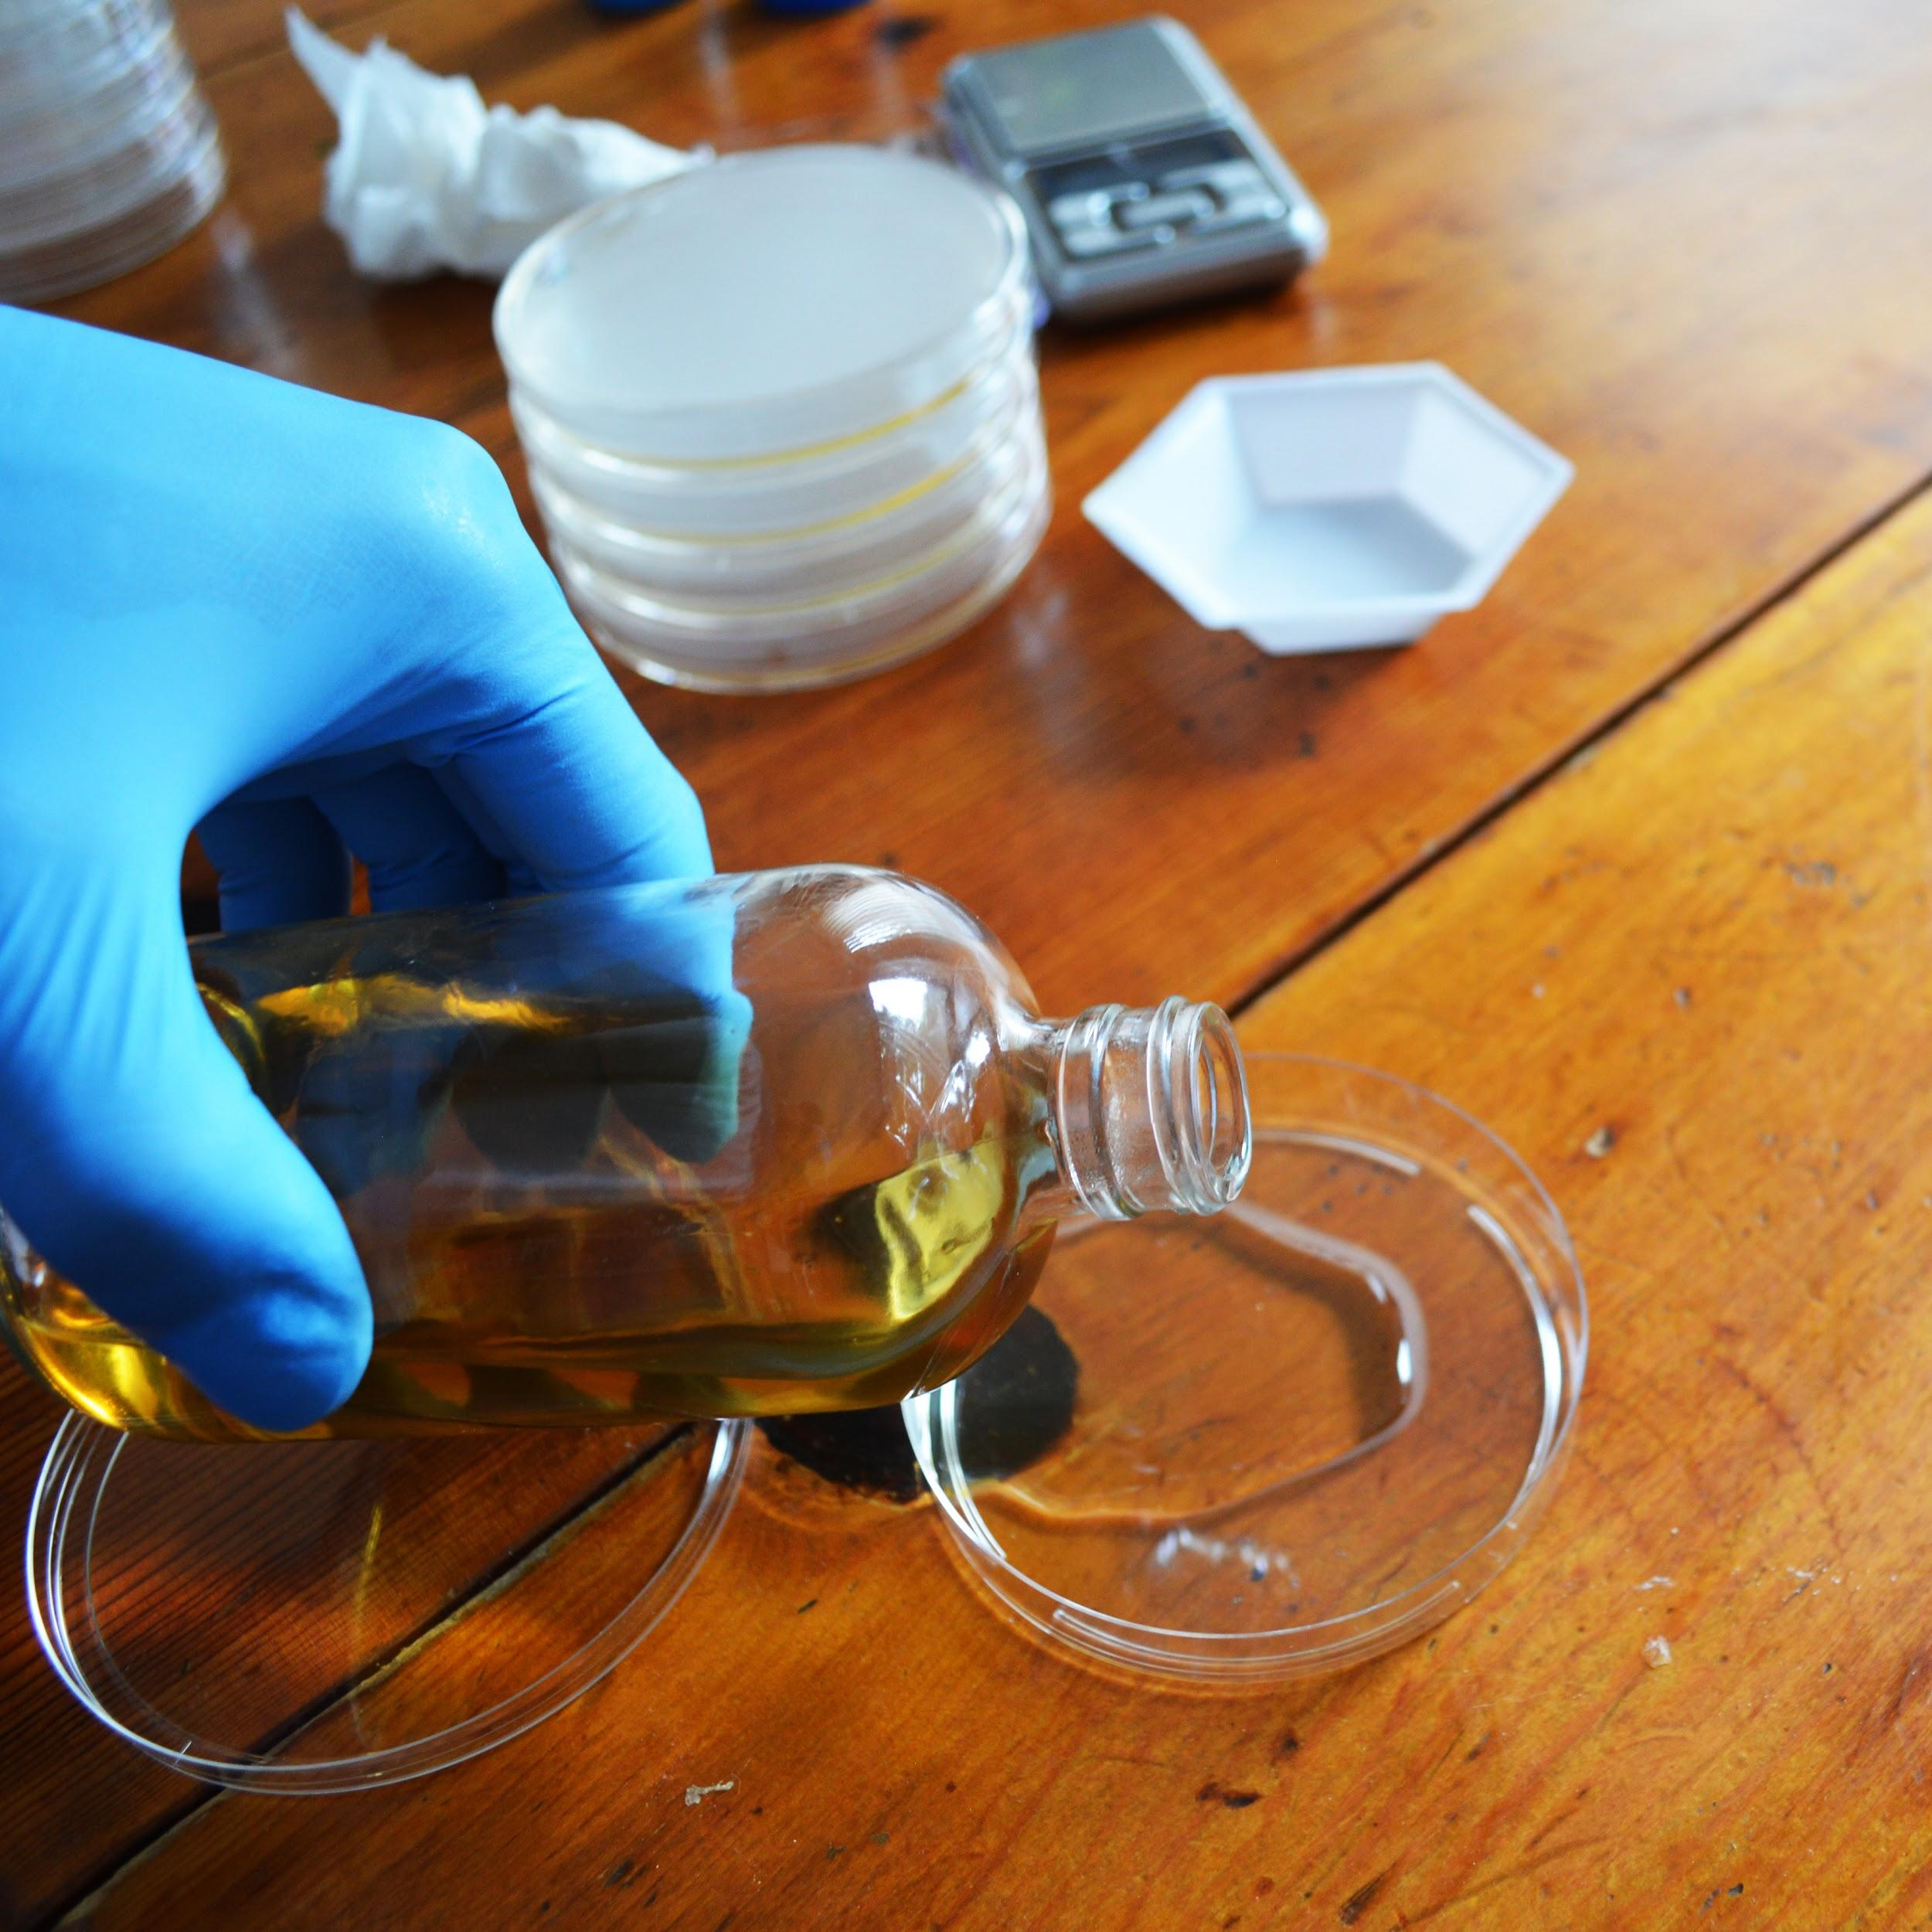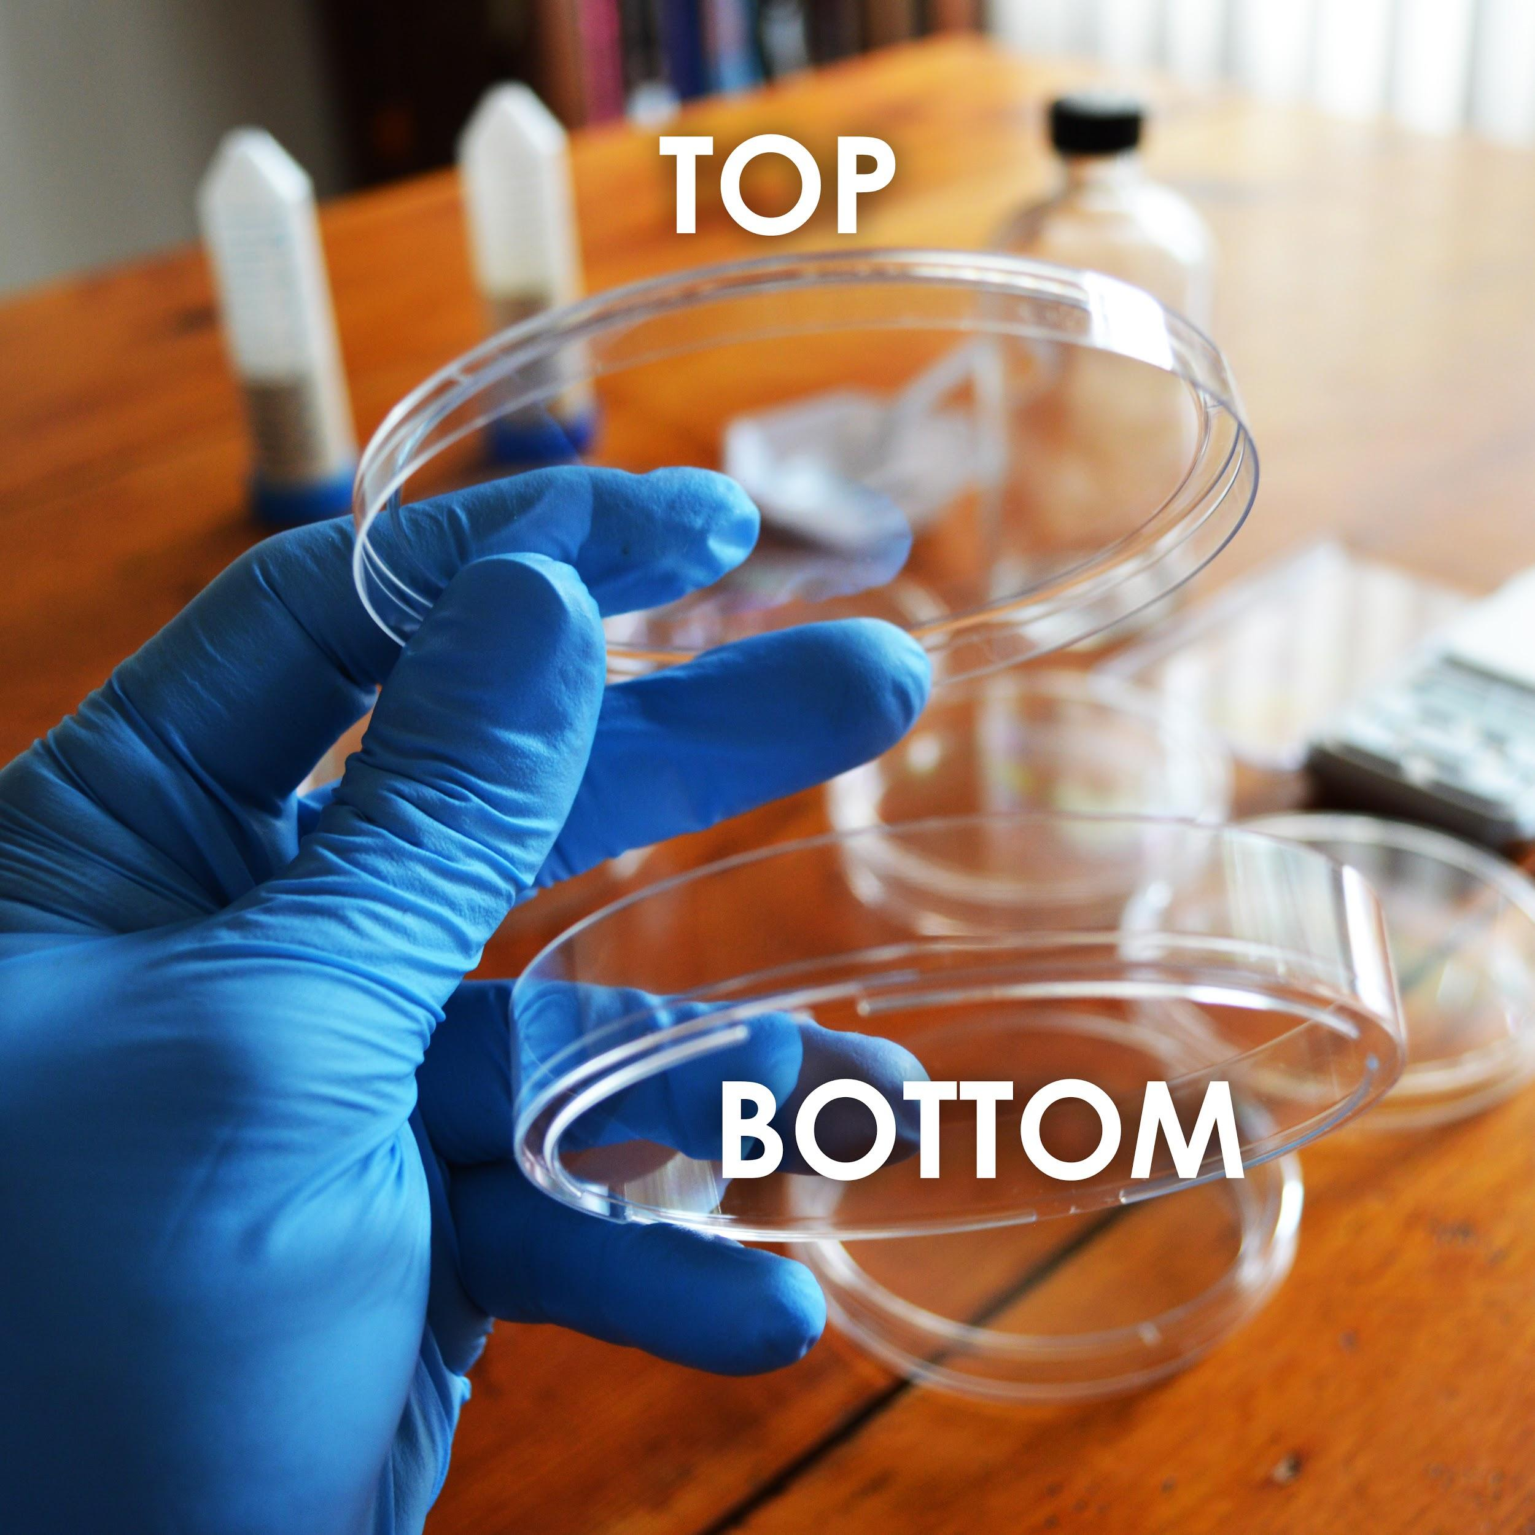

Pour enough to fill the bottom of the plates and place the lid on top. They take around 30 minutes to solidify but this process can be sped up by placing them in the fridge NOT freezer.

Leave plates out few hours or overnight on a table or counter if possible. This lets some of the condensation escape back out before you store them at 4C in your Refrigerator. Store upside down so any condensation doesn’t drip on the plate.

Remember never to freeze plates they will become cracked and distorted.

Plates can be used immediately after they solidify!

Plates should last 2-3 months depending on how much condensation accumulates in the bag and how sterile you were during the preparation.

Below are examples of plates where the LB AGAR was heated properly and not properly

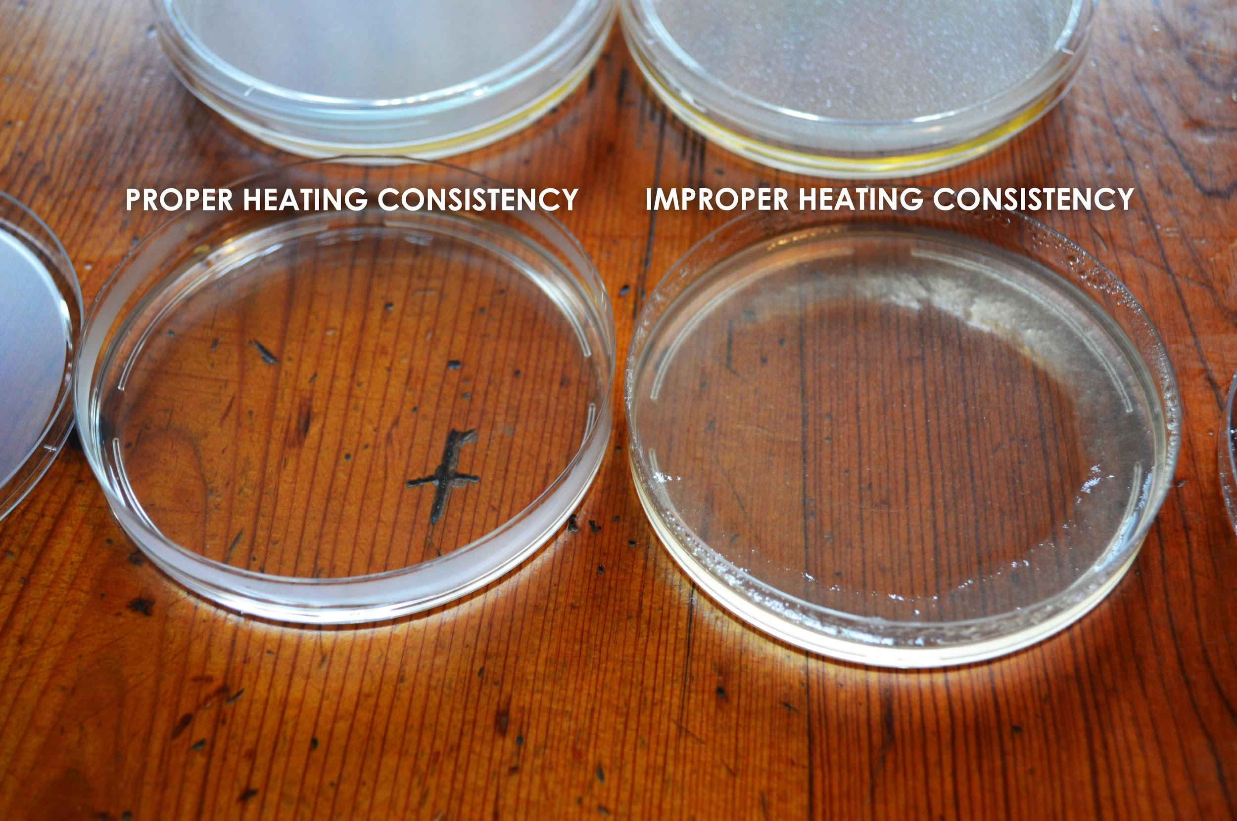

For Video Instruction: [How to Pour Plates](https://www.youtube.com/watch?v=46vy4GylcNY)